10) ARRAYS
Code:-
#include<stdio.h>
#include<stdlib.h>

int main()
{
int Fav_Numbers[] ={1, 2, 3, 4, 5, 6, 7, 8};
printf("%d", Fav_Numbers[7]);
return 0;
}
Hint= arrays contain multiple data;
OUTPUT:-

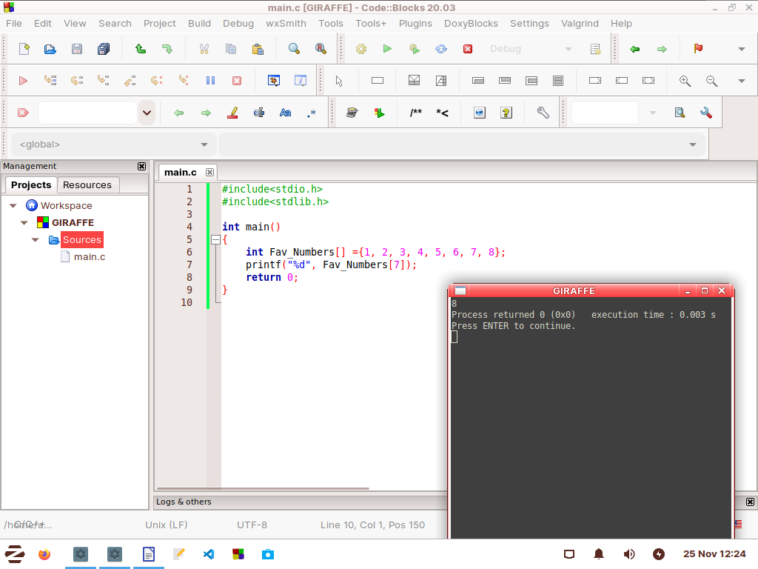

Change the value of data in array:
CODE:-
#include<stdio.h>
#include<stdlib.h>

int main()
{
int Fav_Numbers[] ={1, 2, 3, 4, 5, 6, 7, 8};
Fav_Numbers[2]= 199;
printf("%d", Fav_Numbers[2]);
return 0;
}

OUTPUT:-
